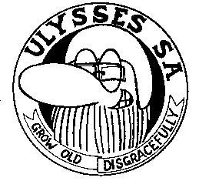
JO.BURG SOUTH

NEWSLETTER MARCH 2015
12 March 2015 meeting was chaired by our Chairman Frik. Absent were Tok/Santa/
JJ/Brian/Vivian/Ray/Elsie & Ray C. Guest was Gavin.
The 2015 Ulyssses Rally was one of the main topics-all monies were to be paid over
to Frik before the end of March! The same goes for membership fees for 2015.
If members have items to be discussed at the Ulysses National AGM in May, please
discuss with Frik at the April meeting.
Rally shirts which are being organized by Mark L-G, well there will be a change of
position of patches, and price to be discussed at April meeting, please bring moola.
The Charity run to Parys, organized by Gerda & Dion, was a great success and Gerda
has pics.
The club sends condolences to Ray W, for the passing of his brother, and then his Mom,
Ray you are in our thoughts and prayers.

Scrolls were handed out to:
Andre Ou Stille Welcome to Jo.burg South
Nikke Stoutgat Welcome to Jo.burg South
Dion Ramsy
Gerda My Cookie
Mike Tutti Frutti (Received scrolls in both pink & blue)! So sweet
Frik Gogga

Birthdays for March --- Ray W on 15th (did not attend meeting, as he was away on
conference.) Mark states that a fine is due by you, as you
were not there to receive his gift !!!!
Birthdays for April --- Meghan – 3rd - hope it was a good one, and you were spoilt
Nikki – 26, may your 29th birthday be wonderful

FRIK/TOK catered - so lekker (maybe you guys should cater every month)
ED/CAROL to cater for April meeting
APRIL MEETING - 16th April 2015 (Jeff & Nicky will still be away on their bike
trip. Hope you guys will be safe on the roads & have fun)
Raffle winners = Tony won the cell phone
Eddy won the lekker pen knife

Cheers – Be safe on the roads and have a blessed Easter

